NAAN MUDHALVAN PROJECT

**Store Manager-Keep Track Of Inventory**

1. Introduction

# Project Title: Store Manager-Keep Track

# Team id:NM2025TMID46225

Team leader Name:THILAKARASI K

Mail id : thilakarasithilak5@gmail.com

Team Members:

1. VARSHINI.K– varshinikumar9894@gmail.com Demo video making

# 2.VIDHYASRI.K– [vidhyakannan9025@gmail.com -](mailto:%20vidhyakannan9025@gmail.com%20%20-) Code Developer

3 GOWSALYA.S – **gowsalyaselvam259@gmail.com** - Document

**2. Project Overview**

* **Purpose**:  
  To help store managers efficiently track stock levels, manage product information, monitor sales, and prevent shortages or overstocking.
* **Features**:
  + Add, update, delete products
  + Track stock quantity
  + Low-stock alerts
  + Search/filter products
  + Dashboard with sales & stock overview

**3. Architecture**

* **Component Structure**:
  + App.js → Root component
  + Header → Navigation bar
  + ProductList → Displays all products
  + ProductForm → Add/Edit product
  + InventoryDashboard → Shows stock summary & alerts
  + Footer → Footer details
* **State Management**:
  + Context API (or Redux if advanced) for product state
  + Local state for forms
* **Routing**:
  + react-router-dom for navigation between Dashboard, Products, Add Product, etc.

**4. Setup Instructions**

* **Prerequisites**:
  + Node.js (LTS version)
  + npm or yarn
* **Installation**:
* git clone <repo-url>
* cd inventory-app
* npm install
* npm start

**5. Folder Structure**

inventory-app/

├── public/

├── src/

│ ├── components/

│ │ ├── Header.js

│ │ ├── Footer.js

│ ├── pages/

│ │ ├── ProductList.js

│ │ ├── ProductForm.js

│ │ ├── Dashboard.js

│ ├── context/

│ │ ├── ProductContext.js

│ ├── assets/

│ │ ├── images/

│ ├── App.js

│ └── index.js

└── package.json

* **Utilities**:
  + utils/validation.js → for input validation
  + utils/alerts.js → for low-stock alerts

**6. Running the Application**

cd inventory-app

npm start

The app runs at http://localhost:3000

**7. Component Documentation**

* **Key Components**:
  + ProductList: Displays all inventory items
  + ProductForm: Form to add/edit product
  + Dashboard: Stock summary, low stock alerts
* **Reusable Components**:
  + Button, Modal, InputField

**8. State Management**

* **Global State**:
  + Product list stored in ProductContext
* **Local State**:
  + Form fields handled with useState

**9. User Interface**

* Product List page (Table with Name, Quantity, Price)
* Add Product page (Form)
* Dashboard page (Summary + Alerts)

**10. Styling**

* **CSS Framework**: Tailwind CSS or Bootstrap
* **Theming**: Simple, professional store dashboard look

**11. Testing**

* **Strategy**:
  + Unit test: Add Product function
  + Integration test: Adding & Displaying in ProductList
* **Tools**: Jest + React Testing Library

**12. Screenshots / Demo**

(Insert screenshots of UI: Dashboard, Product List, Add Product form)

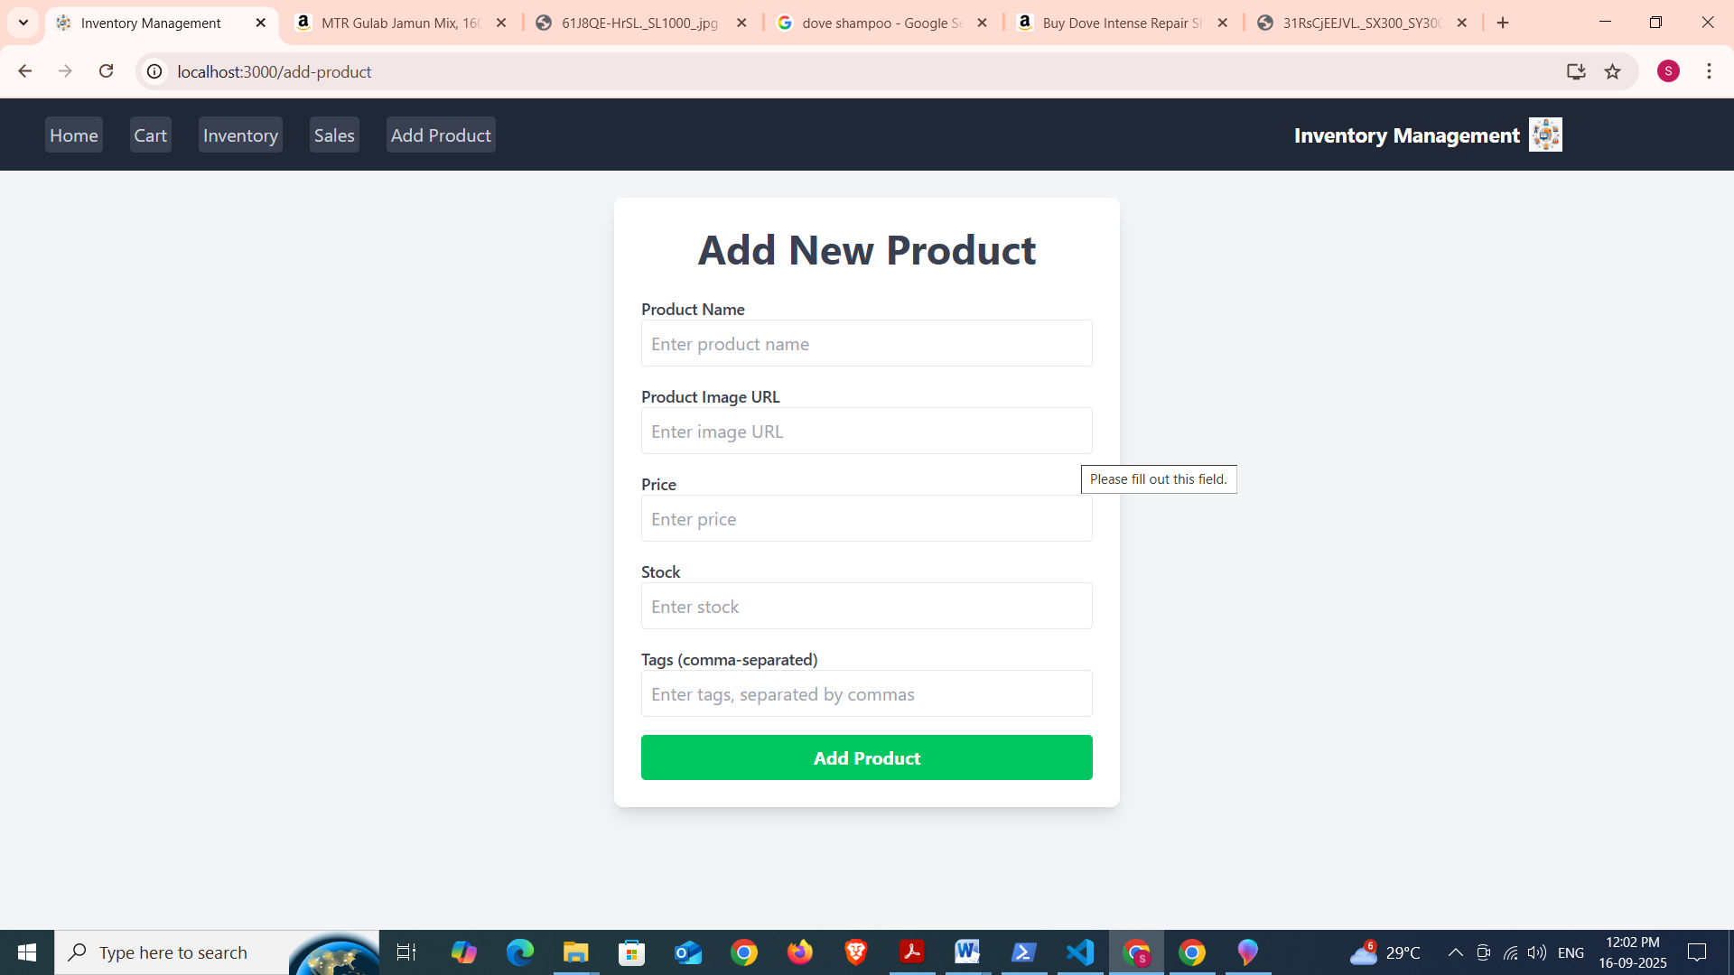

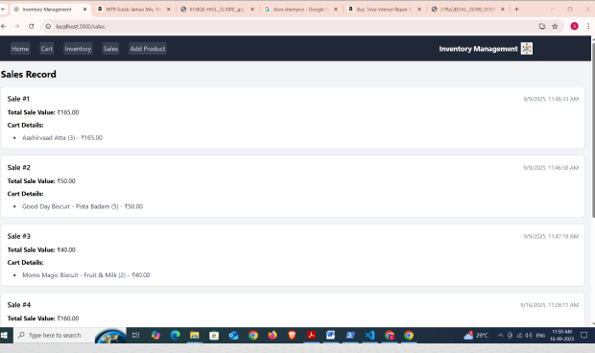

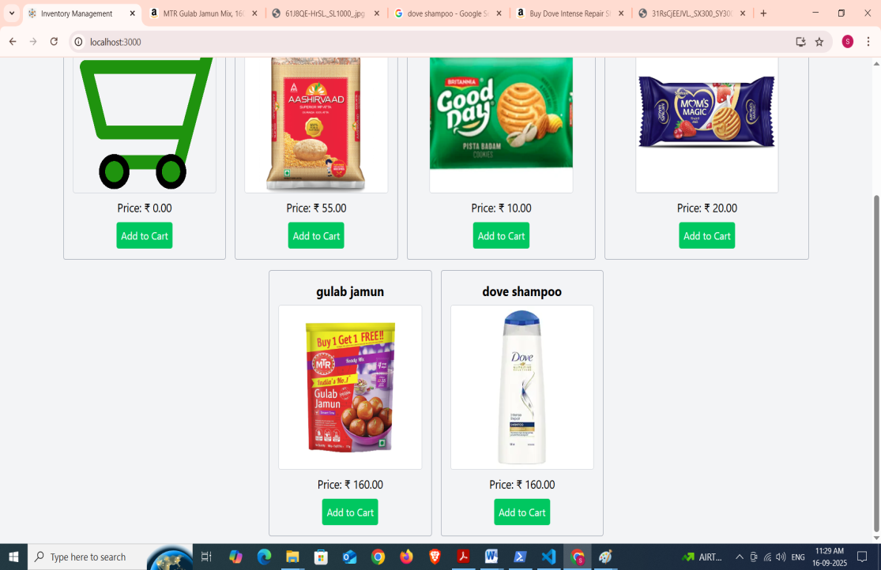

**13. Known Issues**

* Product data resets on page refresh (if no backend used)
* Limited reporting features

**14. Future Enhancements**

* Add authentication (login for store manager)
* Connect with backend + database (MongoDB / Firebase)
* Export stock reports to Excel/PDF
* Barcode scanning integration

# Future Enhancements

Add shopping list generation from recipe ingredients Introduce push notifications for new recipes

Offline mode for saved recipes